**Documentation:**

**Softwares used to complete this test:**

Visual Studio 2013

SQL Server 2012

**Technologies:** C#,ASP.NET MVC,ORM,Bootstrap,HTML,LINQ

**Procedure:**

* Created the ASP.NET website project using MVC architecture
* Used Entity Framework for contacting the database
* Designed the application using bootstrap

**GUESS THE ANIMAL Screenshots**

1. **Guess the animal page**

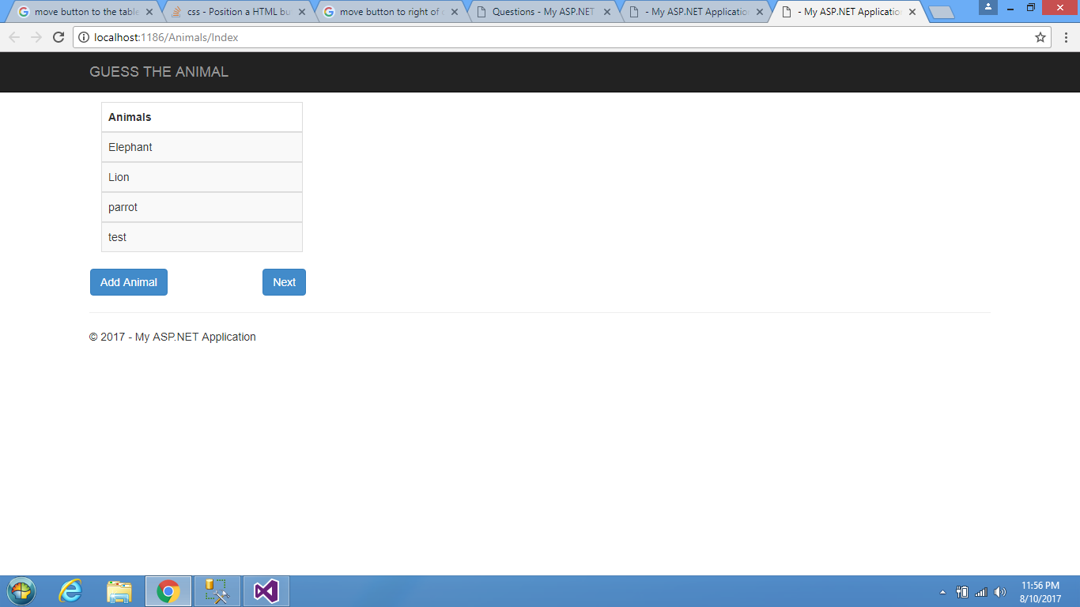

1. Upon clicking on NEXT button

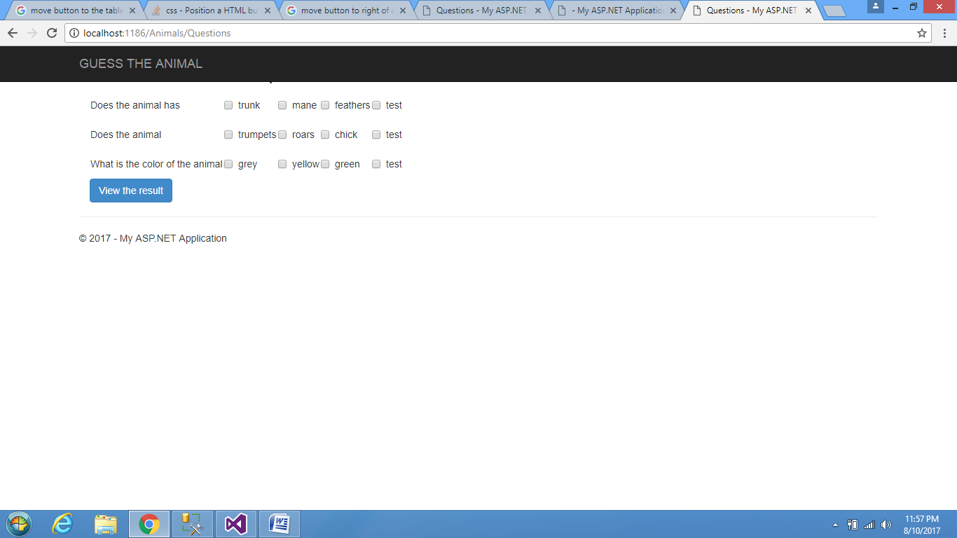

1. Selecting the identities

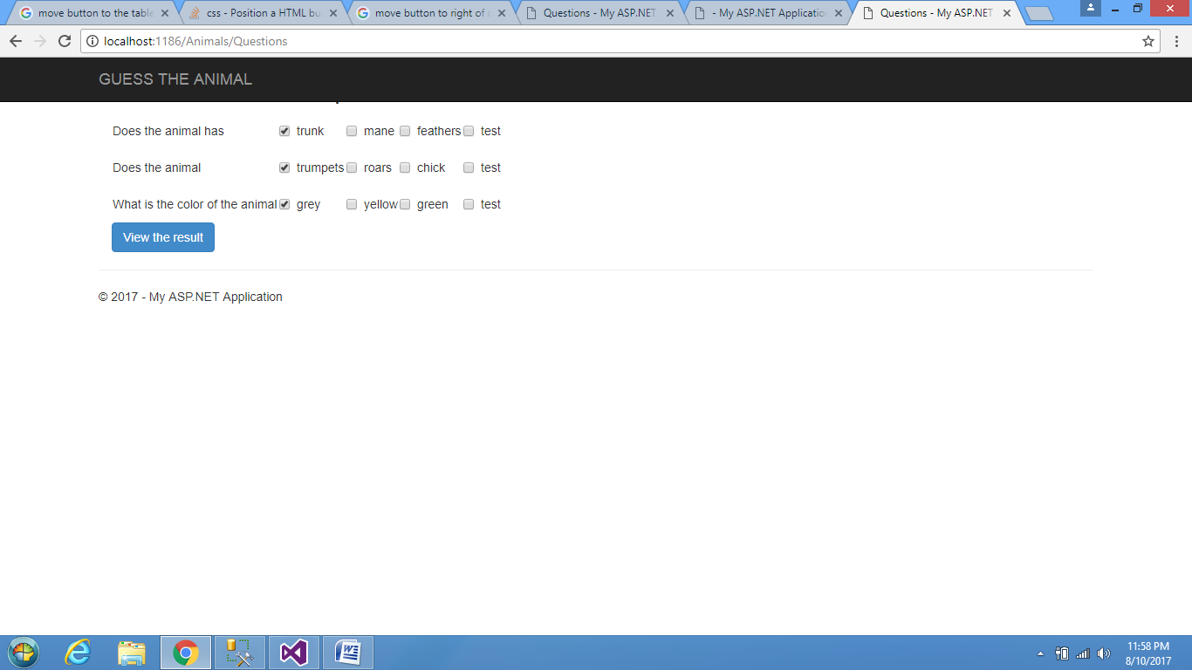

1. Output to the user

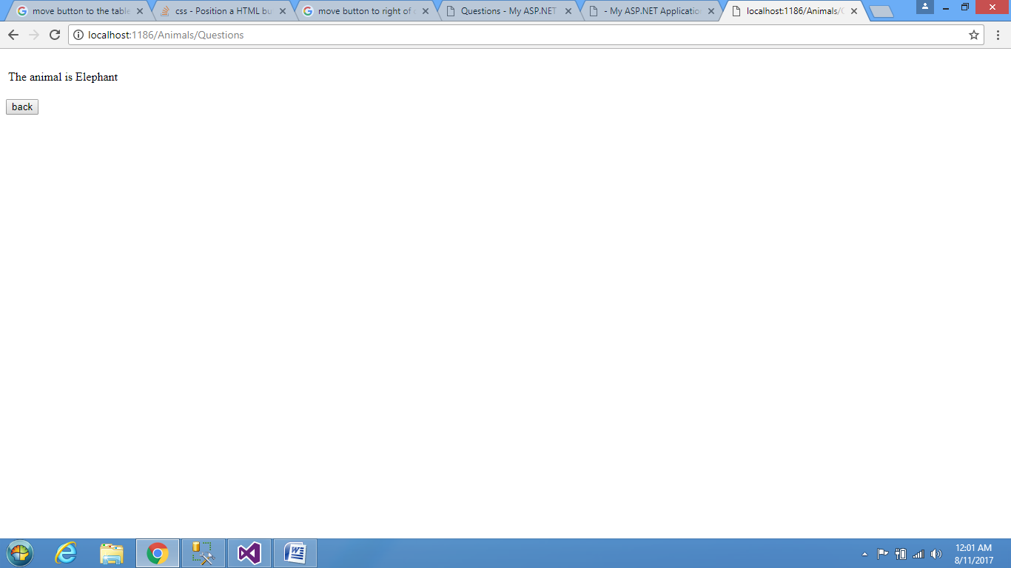

1. Adding the new animal

